#3.
- See figure below, the letter e assumes a backwards and an upside-down position

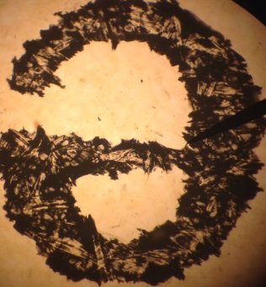

- 40x
- The e is backwards and upside-down
- The diaphragm
- To the right
- Towards you
#4. The image of the letter e has become bigger and it’s still fully visible
#5.
- No, letter e is not entirely seen
- Smaller
#6.
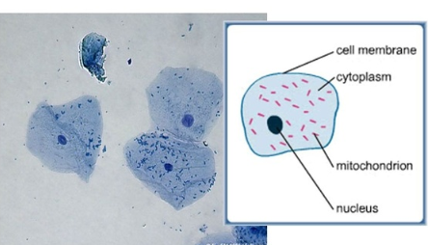

#7.
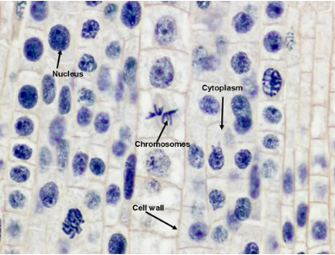

#8.
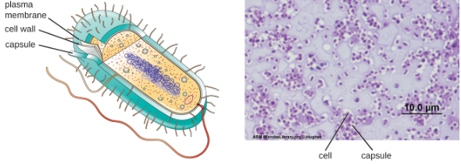
#9.
Nucleoid

#10.
- bacterial cells
- bacterial cells
- animal cell
#11.
- Chloroplasts, central vacuole, and cell wall
- ribosome
- flagella
- cell wall and cell membrane
- mitochondria
- smooth endoplasmic reticulum
- nucleus
- cytoplasm
- cell membrane

#1.
- Stage controls
- Stage
- Objectives
- Ocular lenses
- Arm
- Diaphragm
- Power switch
- Coarse adjust
- Fine adjust

#2.
Lens | Magnification of Objective Lens | Magnification of Ocular Lens | Total Magnification of Specimen
Scanning | 4x | 10x | 40x
Low | 10x | 10x | 100x
High | 40x | 10x | 400x
Oil immersion | 100x | 10x | 1000x

